Kevin, you are Right-brained, which means that the right hemisphere of your brain is dominant over your left.
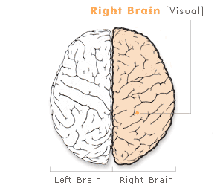
Typically, right-brained individuals like you are creative, imaginative, and particularly attuned to their surroundings, whether catching the nuances of music, discerning artistic elements, or noticing spatial relationships between different forms. We know this because researchers notice increased activity in the right hemisphere of the brain in individuals hooked up to monitors when they play music or ask them to complete a task involving spatial relationships.
Though thinking logically might be something you have to do sometimes, you are also good at stream of consciousness thinking and making tangential jumps in logic or reasoning. You are more intuitive than many. And when it comes to pleasure reading, you might have a stronger preference for creative or fiction writing than nonfiction.
Your test results show that you are a visual learner.
Other right-brained people who are also visual learners are Albert Einstein, the painter Vincent Van Gogh, and Microsoft founder Bill Gates. But before delving deeper into how you learn, you should get the basics of your brain's physiology.

